MACH4METAL

metalworking machinery
Transito 21,
6909 DA BABBERICH, Netherlands
Tel. + 31 (0)316 – 247123
Fax. + 31 (0)316 - 247956

Bank No : 66.52.13.883
IBAN : NL33 INGB 0665 2138 83
BIC : INGBNL2A
info@mach4metal.com www.mach4metal.com www.mach4metal.com

DMG NEF 600 C Axis and Live tools
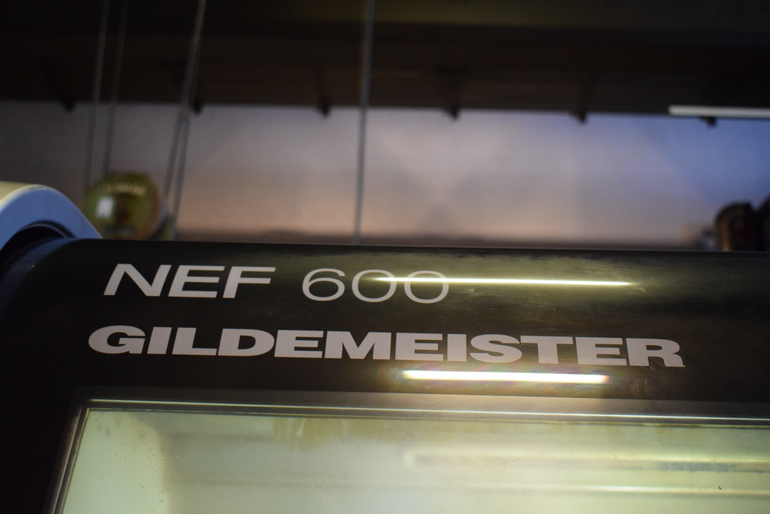

- Make : DMG Germany
- Type : NEF 600
- Age : 0163 0004 A
- Mach. No. : 2009

- Max. turning Ø bed : 600
- Centre height : 300
- Centre distance : 1.190

- Spindle bore : 90
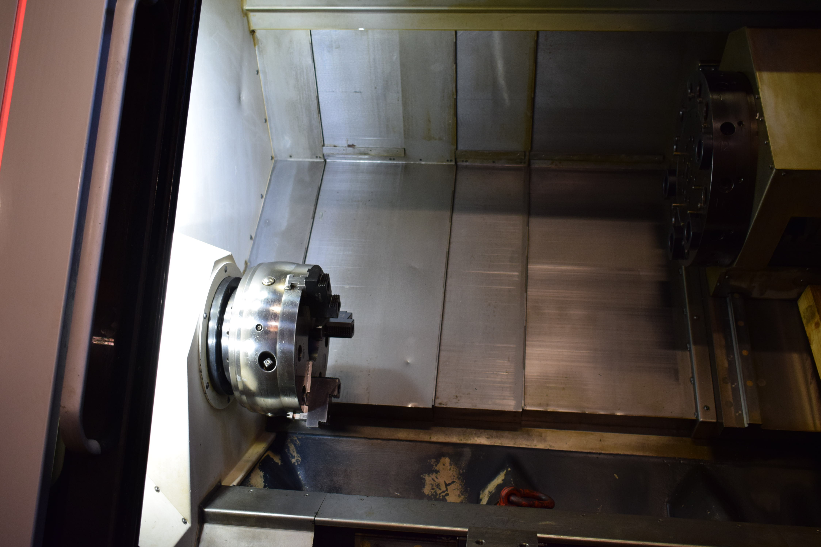
- Speeds 3 ranges : 3.000

- X travel : 398
- C Axis travel : 360.000

- Turret positions : 12 stations
- Live tool speed : 4500 Rpm
- Feed rate : 30 M/Min

- HeidenHain CNC PILOT 4290
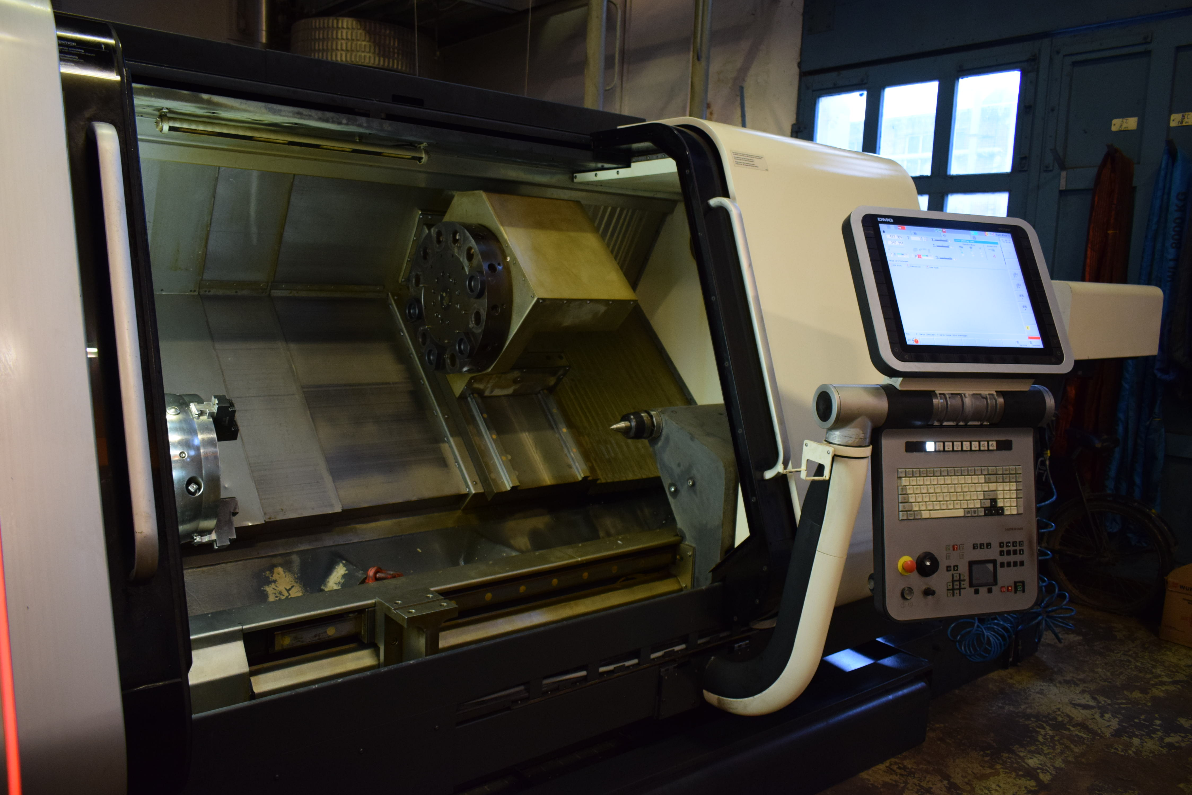

- Chip conveyor
- Coolant system
- Chuck ROTA-S plus 315

- Dimensions:
- Length : 3.550
- Width : 2.700
- Height : 1.900
- Weight : 6.000

Please Note: The above information has been obtained to the best of our ability and belief from, and from the manufacturers where possible. It is given in good faith, but its accuracy can not be guaranteed. Accordingly, it will not form a representation or constitute contractual terms. We advise you to check any vital details !

